Cell Cycle and Reproduction Study Guide
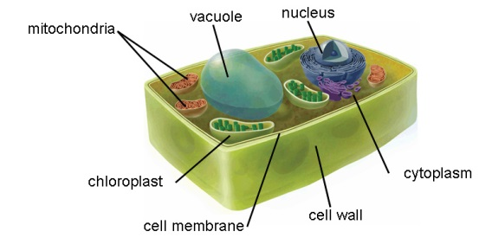
1. Looking at the picture below, what is the role of the chloroplast?

2. What substances are products of cellular respiration but are the reactants in photosynthesis?
3. What are the last two phases of the cell cycle (think mitosis…)?
4. What effect does asexual reproduction in mitosis have on genetic variation?
5. In what ways are sexual and asexual reproduction different from one another?
6. What type of reproduction leads to genetic variation—sexual or asexual?
7. What is cancer caused by?
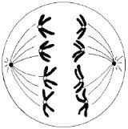
8. Looking at picture below, what stage of mitosis is this showing?

9. Which row in the chart below indicates the correct process for each event indicated?
Row | Formation of egg | Formation of sperm | Growth of embryo
1 | Mitosis | Mitosis | Meiosis
2 | Mitosis | Meiosis | Mitosis
3 | Meiosis | Meiosis | Mitosis
4 | Meiosis | Mitosis | Meiosis

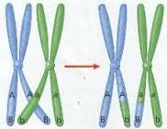
10. What process does the picture below show?

11. What kind of cells does meiosis occur in?
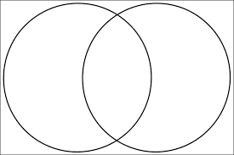
12. Compare and contrast mitosis and meiosis.

13. Why would sexual reproduction be advantageous in a changing environment?

14. What is the advantage to crossing over?
15. In what stage of meiosis does crossing over occur?
16. What do catalysts do?
17. What process is cell death called?
Apoptosis
18. When is asexual reproduction advantageous?
19. What gas is removed from the atmosphere during photosynthesis?
20. What is the process called when small uncharged molecules move from and area of higher concentration to an area of lower concentration?
21. What organelle contains DNA and RNA in eukaryotic cells?
22. What are the differences between active and passive transport?

23. What structures do plant cells have that animal cells do not?
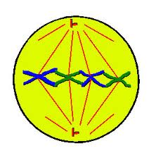
24. Looking at the picture below, what stage of mitosis is this?

25. What part of the cell conducts protein synthesis?
26. What is not included in the cell theory?
a. living things appear spontaneously
b. the cell is the basic unit of life
c. new cells are formed only by division of a preexisting cell
d. all living things are composed of one or more cells
27. Cellular eating is another name for which of the following?
a. plasmolysis
b. exocytosis
c. pinocytosis
d. phagocytosis
28. In what stage of the cell cycle does the cell carry out its normal function, and continues to grow before division?
29. Is endocytosis a type of passive transport?
30. What process makes glucose in plant cells?

