Cell Questions
1. You are observing a cell underneath a microscope. You find that it has a nucleus and membrane-bound organelles. How would you classify this cell?
2. What helps to increase the rate of chemical reactions?
3. What organelle in plants is responsible for storing waste, food and water?
4. What does the cytoplasm in cells hold?
5. Describe a prokaryotic cell.
6. Does the activation energy during a chemical reaction get lowered or raised once an enzyme is added?
7. Where is RNA stored in a cell?
8. Looking at the following choices, what is found in both animal and plant cells (you can choose more than one)?
a. chloroplasts b. lysosomes c. ribosomes d. nucleus e. mitochondria
9. True or false: A plant cell is a prokaryote
10. What is the function of rough ER? Smooth ER?
11. You are looking at an animal cell underneath a microscope. You notice that the cell is unable to make proteins. What part of the cell is not working?
12. What do cells use to control what goes into and out of cells?
13. What do plant cells have that animal cells DO NOT?
14. What structure in plant cells is close to the cytoskeleton in animal cells?
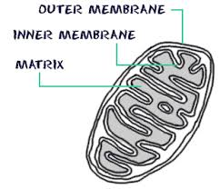
15. What would not be made if the organelle below in animal or plant cells stopped working?

16. How was the cell theory proved?
17. Which of the following is stated in the cell theory?
a. all cells contain DNA c. all cells reproduce
b. all cells have ribosomes d. the cell is the basic unit of life
18. If several organelles stopped working in an animal cell, what organelle would be responsible for breaking down those organelles using enzymes?
19. Which cell structure is correctly paired with its primary function?
a. ribosome-movement c. vacuole-storage of waste, water, food
b. mitochondria-protein synthesis d. nucleus-makes energy
20. What do animal cells have that plant cells lack?
a. cytoskeleton, ribosomes c. cell wall, rough ER
b. cytoskeleton, lysosomes d. cell wall, chloroplast
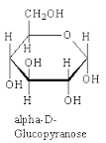
21. Looking at the following picture below, what type of macromolecule is this?

22. If a plant cell had many damaged chloroplasts, what process would start to break down?
23. What criteria is used to characterize a eukaryote from a prokaryote?
24. What does the theory of endosymbiosis explain?
25. If someone claimed that cells arise spontaneously from inorganic particles, how would you disprove their statement using the cell theory?
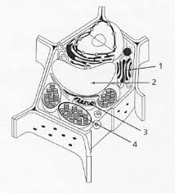
26. Looking at the plant cell below, what is number 2 pointing to?

27. What is wrong with this statement, and explain your reasoning: all cells have the same size, shape, and function.
28. What structures are found in a cell membrane?
29. What are the functions of proteins?
30. Water molecules are polar with the
a. oxygen and hydrogen sides being slightly negative
b. oxygen and hydrogen sides being slightly positive
c. oxygen side being slightly positive and the hydrogen side being slightly negative
d. oxygen side being slightly negative and the hydrogen side being slightly positive
31. Water will move higher in a narrow glass tube than in a wide glass tube because of
a. adhesion only c. cohesion only
b. capillary action d. pressure
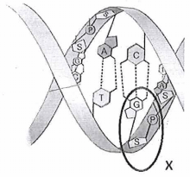
32. Looking at the picture below, what is the circled portion an example of?

a. DNA molecule c. nucleic acid
b. amino acid d. nucleotide
33. Which of the following organic compound is the primary source of transportable (useable) energy in living things?
34. What is wrong with this statement? The nucleus synthesizes proteins.
35. What are the differences between carbohydrates and lipids?

