Cladogram Assignment
Directions: Answer the following questions using the different cladograms and your notes.
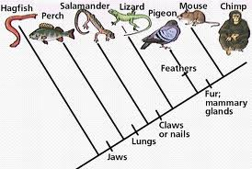
Cladogram 1:

1. Looking at cladogram 1 above, how many derived characters are there?
2. In cladogram 1, list the organisms that have jaws.
3. Which of the following is more closely related to a lizard?
a. Hagfish c. Pigeon
b. Salamander d. Perch
4. What derived character does a lizard, pigeon, mouse and chimp share?
5. What derived character does the mouse and chimp share?
6. What is the only organism that contains feathers?
7. Which organisms don’t have lungs?
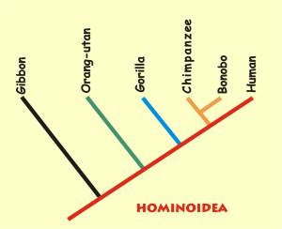
Cladogram 2:

8. Looking at cladogram 2, are gibbons and humans considered to be closely related? Why or why not?
9. Looking at cladogram 2, are chimpanzees and bonobos closely related? Why or why not?
10. What is more closely related to a human: gorillas or chimpanzees?

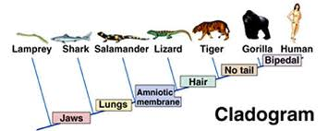
Cladogram 3:

11. In cladogram 3, what organisms contain an amniotic membrane?
12. In cladogram 3, what two organisms are the least related?
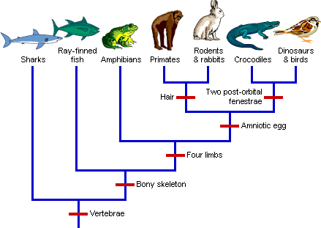
13. What organisms have no tail?

Cladogram 4:

14. In cladogram 4, how many organisms have a bony skeleton?
15. List the organisms that have four limbs.
16. Which organism is more closely related to a crocodile: primates or amphibians?
17. What do primates, rodents, and rabbits share?
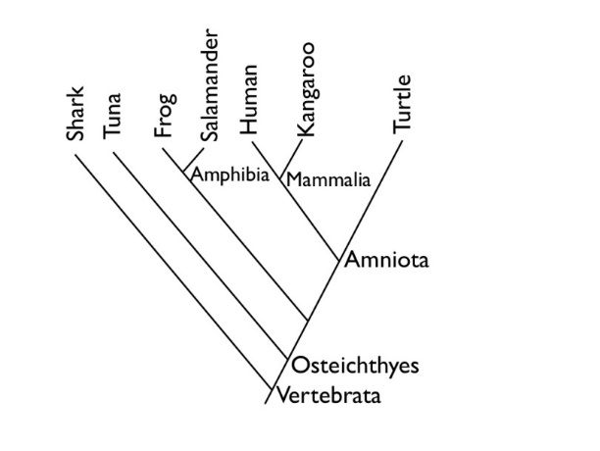
Cladogram 5:

18. Write two examples of amphibians.
19. Which organism(s) are vertebrates?
20. List the organisms that are considered Amniota.
21. What are two examples of mammals.

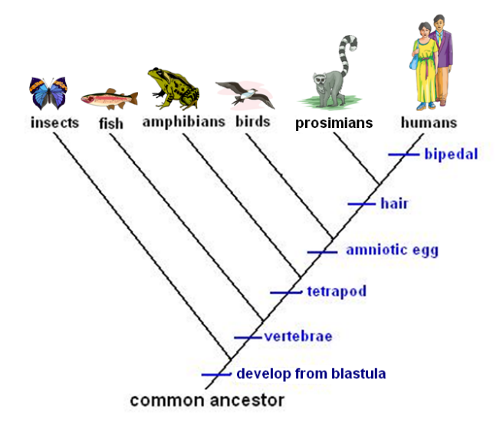
Cladogram 6:

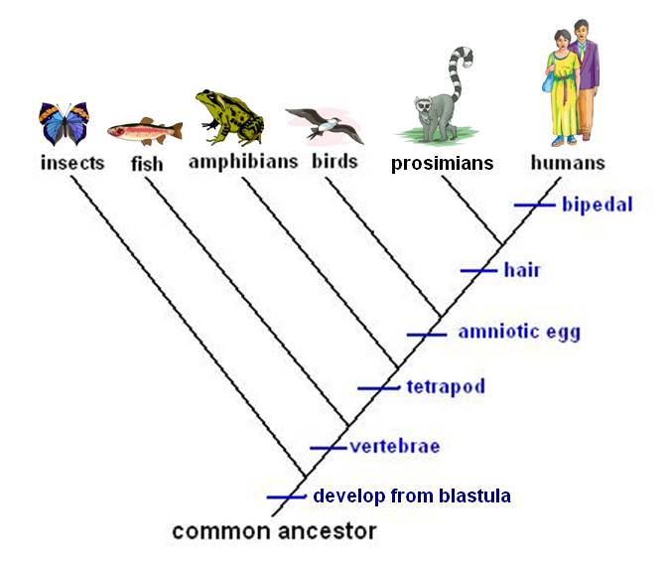
22. In cladistics, an outgroup is a group of species that shares no derived characters with the other groups being studied. In cladogram 6, what is the outgroup? Why?
23. What organism(s) is/are bipedal?
24. What organisms have an amniotic egg? List all!
25. What do insects lack that the rest of the organisms on this cladogram have?

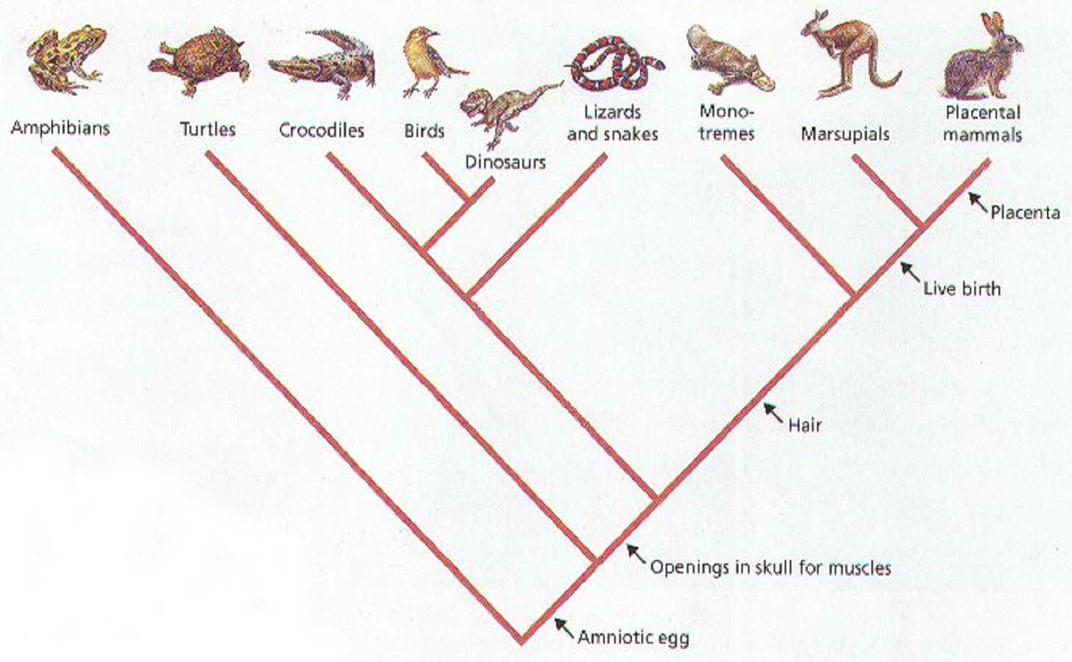
Cladogram 7:

26. In cladogram 7, what derived character do monotremes, marsupials, and placental mammals share?
27. How many organisms have openings in the skull for muscles?
28. What organism is more closely related to dinosaurs: crocodiles, lizards and snakes, or birds?
29. Why are cladograms used?
30. Fix this sentence on your own paper: All species below a hash mark share the derived character.

