Cycle 3 Review
Evolution:
- The skull, spinal column, leg and hip bones in hominids differ from primates. What advantage did this give hominids?
- Between similarity in environment, similarity in behavior, similarity in anatomy and similarity in DNA, which one would scientists use the most to see the evolutionary relationship between two organisms?
- What are analogous structures? Give an example.
- What are homologous structures? Give an example.
- Why are fossils that are found in sedimentary rock so important to scientists when observing evolutionary change of organisms’ overtime?
- Why do chimpanzees and humans share so much DNA (hint: what does this imply about us and chimps…)?
- If there was a volcanic explosion and some organisms died by chance but others survived, what is this an example of? Hint: this causes a random change in allele frequencies…
- A mutation causes a bird to have gray coloration instead of bright green feathers like other birds in their population. In what type of situation would the gray bird survive, but not the green birds?
- Variation in populations is really important in case the environment they live in suddenly changes. For example, an insect develops resistance to pesticide but not others. Why would this be beneficial?
- A fish population in a lake has small and larger sized fish of the same species. Scientists observe that the large fish are preyed upon more easily than small fish. What would happen to the fish population over a long period of time? What would you see more of?
- If an environment suddenly changes, it puts a strain on all organisms in the population. What would happen to the organisms population over time? Hint: think about resources available in the environment….
- Geologists have found well preserved fossils of a fish species on land close to the Pacific Ocean. These fossils are similar to fossils of an ancient fish species that lived in the Atlantic Ocean millions of years ago, close to the Pacific Ocean. What could explain how the fossils from the Pacific Ocean could be similar to fossils from the Atlantic Ocean? Hint: think about a niche…
- Two species of fish live together in a large lake. Species A are very similar to one another, but species B has a lot of variation in many traits. Which species has the advantage? Why?
- Out of the following organisms, what had to be the earliest form of multicellular life on Earth?
- Fish c. land plants
- Invertebrates (no back bone) d. reptiles
- Which of the following is a correct statement about the relationship between natural selection and evolution?
- Natural selection results from evolution
- Natural selection includes evolution as a part of it
- Natural selection is one mechanism of evolution
- Natural selection and evolution are the same thing
- What got smaller in hominids over time, and as a result of the structure getting smaller, what structure increased in size?
- Vegetation can be sparse in areas of Africa. This can put a strain on giraffes because some may not be able to reach leaves high up in a tree, but others may survive. What adaption changed over time in giraffes?
- List the parts to Darwin’s theory of natural selection.
- If different species of organisms have similar structures to ancient fossils, what does this imply about these organisms?
Origin of Life
- Which of the following was NOT characteristic of Earth before the oceans formed?
- Volcanic activity
- Bombardment by comets and asteroids
- An atmosphere containing ammonia and methane
- An atmosphere containing free oxygen
- One necessary condition for the evolution of the first life on Earth was
- The presence of DNA
- The presence of liquid water
- Abundant oxygen in the atmosphere
- The presence of photosynthetic organisms
- One of the accepted scientific theories describing the origin of life on Earth is known as chemical evolution. What event would need to occur FIRST for life to evolve?
- The origin of genetic material
- The beginning of photosynthesis
- The synthesis of organic molecules
- The formation of a plasma membrane
- Would an organism who requires oxygen to survive on early Earth thrive? Why or why not?
- During the 1950s, chemical evolution was a big topic to study. Stanley Miller and Harold Urey conducted experiments in which they fired electrical sparks in the presence of a mixture of different gases. How did these experiments contribute to the theory of the origins of life on Earth? What did their results show?
- The Miller-Urey experiment was created to test what question out of the following choices? (Hint: what did they actually use in their experiments?)
- How did life originate on Earth?
- How does methane gas dissolve in water?
- How does electricity affect methane, water, nitrogen and hydrogen?
- How can a researcher find experimental proof for a hypothesis?
- List the following in the correct chronological order for the evolution of life on Earth:
-synthesis of proteins; abiotic synthesis of amino acids and other organic molecules; evolution of cells; development of a genetic code
Classification
- What do modern scientists now use to reclassify an organism?
- For a long time, algae were considered a part of the plant kingdom. Which statement best explains why most algae are now considered protists and not plants?
- Algae are not motile c. algae obtain energy through photosynthesis
- Algae are not unicellular d. algae do not have organs or specialized tissue
- If an organism is multicellular, sessile and able to make their own food, what kingdom is this an example of?
- How do animal and plant kingdoms differ?
- Looking at the cladogram below, who is more closely related to Animal A?
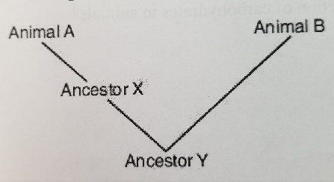
Ancestor X or Y?

- A scientist is working in Africa and has discovered an unknown species of insect. Which of these is most important to consider in classifying the new insect?
- Other insects that are genetically similar
- Other insects that have a similar appearance
- Other insects that live in the same ecosystem
- Other insects that have the same kind of metabolism
- The cladogram below shows the evolutionary relationship among gorillas, humans, chimps, gibbons, siamangs, and old-world monkeys.
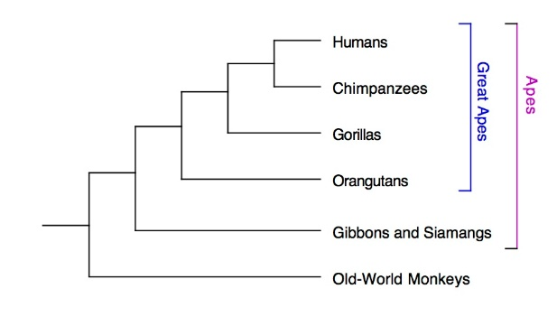

Which pair of animals would likely have the most sequences of DNA in common with each other?
- Chimp and gorilla c. human and chimp
- Gorilla and gibbon d. human and gibbon
- If a scientist were to discover a new organism that is prokaryotic and has a cell wall, but lives in a normal environment, what domain should the organism be classified?
- What are some reasons bacteria are distinguished differently from protists, fungi, animals and plants?
- You discover an organism that is an absorptive heterotroph and has chitin in its cell walls. Into which kingdom should the scientist classify the organism?
- In Linnaeus’s time, all living things were grouped into two kingdoms. Later, there were five kingdoms and now we have six kingdoms. What is the main reason for this increase in the number of kingdoms?
- As scientist learned more about genetics and biochemistry, some organisms were moved out of existing kingdoms and into new ones
- Scientists have discovered organisms that were previously unknown, so new kingdoms had to be created for them
- Kingdom plantae had to be split up into several kingdoms when scientists found that not all plants can photosynthesize
- Since the time of Linnaeus, many new organisms have evolved and most of them don’t fit into the original kingdom
Plants
- If a xylem in a tree were to be badly damaged, what process would be affected by this structure no longer working?
- What is the big process that leaves perform for plant survival?
- The stomata of leaves are usually open in:
- Light if a plant has too little water
- Light if a plant has enough water
- Darkness if a plant has enough water
- Darkness if a plant has too little water
- What is the function of guard cells in plants, and what does the stomata bring into and out of the plant?
- If the xylem and phloem in a plant were damaged, what could it no longer bring up or down in the plant?
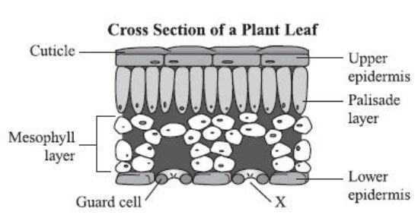
- Looking at the picture below, what does structure X do to contribute to the survival of the plant?

- Looking at the picture below of a flower, what does letter A represent, and what is its function? What about structure B?
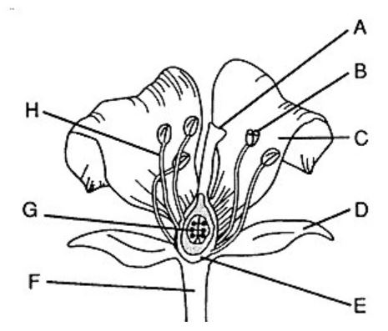

- Plants gain their mass to grow in size by using sunlight and which two components from the environment?
- Water and oxygen c. nitrogen and carbon dioxide
- Nitrogen and water d. water and carbon dioxide
- Which function do roots and stems share?
- Support of the plant body c. intake of water and sugar
- Transpiration d. photosynthesis
- What happens to a plant’s stomata when it is really hot outside? Why does it do this? Explain.
- A plant, by opening and closing its stomata must achieve a balance between:
- Water loss and carbon dioxide c. carbon dioxide loss and sugar uptake
- Sugar loss and oxygen uptake d. carbon dioxide loss and mineral loss
- Why are brightly colored petals on a flower so important to ensure that plants can continue to reproduce?
- What type of tissue in plants transports sugar?
- If an organism eats all the bark on the outside of a tree, why would the tree be susceptible to dying?
- A fleshy fruit surrounds seeds of many flowering plants. In some plants, the fruits are brightly colored. Which of these statements best explains why some plants have developed brightly colored fruit?
- Brightly colored fruits protect plants from insects
- Brightly colored fruits require less of the plant’s energy to develop
- Brightly colored fruits are always act as a warning to animals that the plant is poisonous
- Brightly colored fruits attract animals which eat and disperse the seeds as they pass through their bodies, aiding flower reproduction
Photosynthesis and Cellular Respiration
- A scientist is studying an organism and looking to measure the compounds given off by two of its cells. She finds that cell A produces energy and cell B absorbs carbon dioxide and gives off oxygen. What would be true about these two cells?
- Cell B contains mitochondria and cell A contains chloroplasts
- Cell A contains mitochondria and cell B contains lysosomes
- Cell A contains mitochondria and cell B contains chloroplasts
- Cell B contains mitochondria and cell A contains centrioles
- What gas does photosynthesis absorb, and what gas does cellular respiration use to drive the process?
- In the cycle below, which processes are represented by A and B?
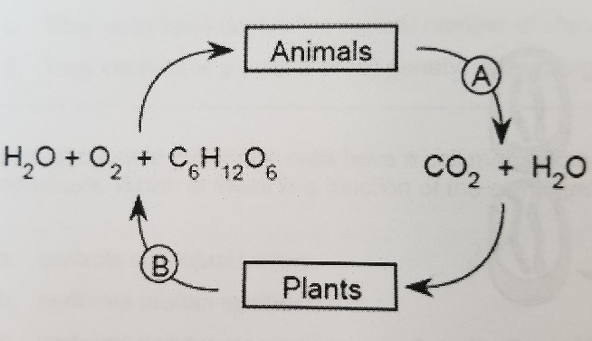
- A-excretion; B-respiration
- A-respiration; B-photosynthesis
- A-transpiration; B-excretion
- A-photosynthesis; B-transpiration

- Write the equation for photosynthesis.
- Write the equation for cellular respiration
- Why is anaerobic respiration considered to be less efficient than aerobic respiration?
- Less ATP is gained using anaerobic respiration compared to aerobic respiration
- More oxygen is required for anaerobic respiration than for aerobic respiration
- Less lactic acid formed during anaerobic respiration than aerobic respiration
- More energy is required during aerobic respiration than anaerobic respiration
- Which statement accurately describes the way that adenosine triphosphate (ATP) transfers energy within a cell?
- ATP molecules break up sugars such as glucose into energy rich compounds like lactose
- ATP molecules ionize oxygen molecules which give up electrons that can be used for energy
- ATP molecules split carbon dioxide molecules, and the carbon is used as fuel by the cell
- An ATP molecule reacts with water and loses a phosphate group, breaking a bond and releasing energy
- The movement of carbon through an ecosystem is related to the flow of energy. What is the role of carbon dioxide in the flow of energy when it comes to plants? Hint: What do plants do with atmospheric carbon dioxide, and what does it make with it along with water and sunlight?
- What function does ATP carry out in organisms?
- A weightlifter is using heavy weights in short bursts for a competition. Because his muscle cells are not able to take in enough oxygen to make very much ATP the weightlifter begins to get fatigue in his muscles. Which of the following processes is most likely going on in the muscles of the weightlifter as he competes in his event?
a. As the cells run out of oxygen they switch to anaerobic respiration, which allows the cell to make small amounts of ATP in the absence of oxygen.
b. As the cells run out of oxygen, they die off gradually and the weightlifter's muscles have fewer contracting muscle cells.
c. The cells will never run out of oxygen if the weightlifter is breathing.
d. As the cells run out of oxygen, they will continue to make the same amount of ATP, since oxygen is not required to make ATP.

