DNA and Protein Synthesis Test Review
- DNA replication – find the complement to the DNA strand in DNA replication shown below.
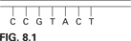

- Where does DNA replication take place?

Nitrogenous Bases (%)
 | A | G | T | C
Human |  | 19.9 | 29.4
Chicken | 28.8 |  |  | 21.5
Bacterium  (S. lutea) | 2  13.4

- The above table is missing some percentages. According to Chargaff’s base pairing rules, fill in all the missing base pairs in the chart.

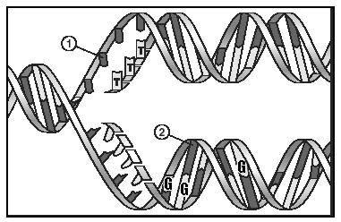
- What nucleotide is going to be added at point 1? At point 2?
- When does DNA replication occur in both prokaryotes and eukaryotes?
- How many codons and amino acid combinations are there?
- What is the function of the enzyme DNA polymerase?
- Find the complement to the DNA strand below in transcription of protein synthesis. Hint….it will be a mRNA strand….
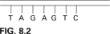

- What does mRNA do in transcription?
- What is the order of how a protein is made? Hint….DNA to RNA to proteins!
11. What is genetic engineering (gene therapy)?
- Why is DNA a good molecule for storing information
- What is the structure below?
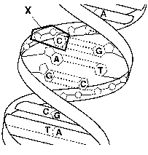

- What three parts make up a nucleotide in DNA?
- What are the base pairing rules in DNA? RNA?
- Understand the percentages of A to T and G to C in DNA.
- What scientist discovered the DNA double helix?
- What is the result of DNA replication?
- What are three differences of DNA vs. RNA?
- What is transcription?
- How many nucleotides are needed to specify three amino acids?
- From which molecule is mRNA transcribed from?
- What is the role of mRNA?
- Explain the difference between transcription and translation.
- Explain the difference between a point and a frameshift mutation.
- What happens when a nucleotide is deleted?

True/False: For numbers 26-30, state whether the statement is true or false. If the answer is false, change the underlined word(s) to make a correct statement.
26. The sugar found in RNA is called deoxyribose.
27. The DNA molecule is double stranded and the RNA molecule is single stranded.
28. The process of translation occurs at the ribosome.
29. The job of mRNA is to pick up amino acids and transport them to ribosomes.
30. Transcription must occur before translation may occur.

31. Which of the following is attached the tRNA (transfer RNA)?
a. DNA b. ribosome c. amino acid d. nucleic acid
32. Which of the following is not part of protein synthesis?
a. replication b. translation c. transcription
33. The codon is located on the
a. mRNA b. tRNA c. rRNA d. DNA
34. In RNA, which nitrogen base is found in place of thymine?
a. guanine b. cytosine c. adenine d. uracil
35. During the process of transcription, which of the following is produced?
a. H2O b. ATP c. mRNA d. DNA
36. The actual site of protein synthesis is the
a. nucleus b. mitochondria c. chloroplast d. ribosome
37. If the DNA template reads “ATA”, which of the following would be the corresponding sequence on mRNA?
a. UAU b. ATA c. TAT d. UTU
38. The genetic code is based upon reading how many bases at a time?
a. 1 b. 2 c. 3 d. 4

39. Some events that take place during the synthesis of a protein are listed below. What is the correct order of the events? (events listed below)
a. mRNA attaches to a ribosome
b. DNA serves as a template for RNA production
c. tRNA bonds to a specific codon
d. Amino acids are bonded together
e. RNA moves from the nucleus to the cytoplasm
Answer Choices:
- B, E, A, C, D
- D, A, E, C, B
- B, C, E, D, A
- C, B, A, E, D

40. Genes for medically important proteins can be cloned and inserted into bacteria as shown in the picture below.
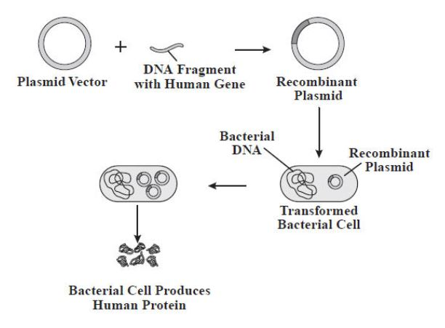

Why can bacteria recognize a human gene and then produce a human protein?

a. DNA replication in bacteria and humans is the same
b. Bacterial cells contain the same organelles as humans
c. The basic components of DNA are the same in humans and bacteria
d. Bacterial cells and human cells contain the same kind of chromosomes
41. Which choice describes DNA after replication has taken place?
a. one molecule with two original strands and one molecule with two new strands
b. two molecules, each with one original and one new strand
c. two molecules, each with two new strands
d. two molecules, each with two old strands
42. The sequence below is part of a gene. How many amino acids are coded for by this segment?
5’ ATCAGCGCTGGC 3’
- 4 c. 12
- 8 d. 20
43. A scientist puts nucleotide chains of UUUUUU in a test tube under conditions allowing protein synthesis. Soon the test tube is full of polypeptide chains composed of only one amino acid, phenylalanine. What does this experiment indicate?
a. The amino acid phenylalanine is composed of thymine
b. UUU codes for the amino acid phenylalanine
c. Protein synthesis malfunctions in test tubes
d. Most proteins only contain one amino acid
44. Which of the following would cause a mutation?
a. the placement of ribosomes on the ER
b. the insertion of a nucleotide
c. the movement of tRNA out of the nucleus
d. the release of mRNA from DNA

Chargaff's rule states that DNA from any cell of any organism has a 1:1 ratio of pyrimidine and purine bases and the amount of guanine, a purine base, is equal to cytosine, a pyrimidine base; and the amount of adenine, a purine base, is equal to thymine, a pyrimidine base.
Example: A=20%, T=20%; C=30%, G=30%
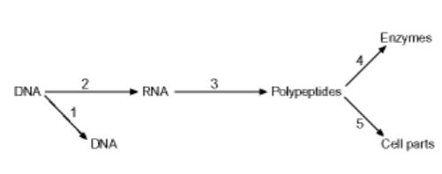
Use the picture below for numbers 45-47.

45. Which process occurs in the nucleus?
a. 1 and 2
b. 2 and 3
c. 3 and 4
d. 4 and 5
46. Process 2 is known as…
a. replication
b. mutation
c. transcription
d. translation
47. What is the product of step 3?
a. a strand of DNA
b. two complementary strands of DNA
c. a strand of RNA
d. a chain of amino acids (protein)

