Ecology Study Guide
Energy in Ecosystems: Food chains, webs and pyramids
1. Using the energy pyramid below, what is true about the amount of available energy comparing the bottom most level to the top level?
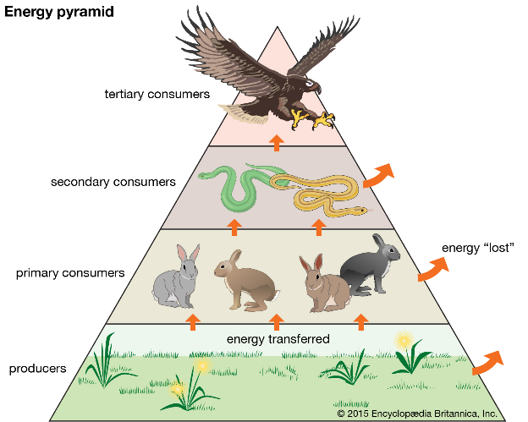

2. What type of organism would be found at the top of an energy pyramid?
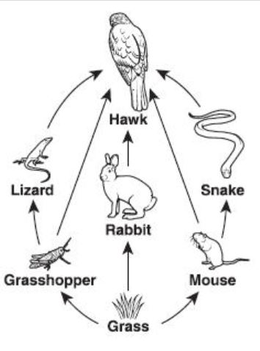
3. A diagram of a food web is shown below:
Which of the organisms receives the least amount of energy from the producers?

4. What is the term used to represent the level of nourishment in food chains and webs?
5. What type of organism is always listed as the second part of a food chain?
6. What is a complex network of feeding relationships (interconnection of food chains) among organisms called?

Population Ecology
7. Data on immigration and emigration of a fish species would be most helpful in determining which of the following?
a. biological magnification c. population size of the species
b. interspecies competition d. predator-prey relationship
8. When an environment has reached its carrying capacity for a certain population, which of the following is true?
a. growth an immigration rate is greater than death and emigration rate
b. growth and immigration rate is less than death and emigration rate
c. growth rate is exponential
d. growth and immigration rate is equal to death and emigration rate
9. How does the predator-prey relationship affect a population?
a. predators and prey are in competition with one another
b. the relationship controls the population size of both species
c. the predator species usually has exponential growth
d. usually either the predator or prey will become extinct
10. Which of the following is a limiting factor in a population of organisms?
a. reproductive replacement
b. lifespan of the members
c. availability of food
d. fluctuations in atmospheric temperature
11. Why is it possible for a population of organisms to reach exponential growth?
12. A pack of wolves has had a decline in the amount of prey in their area, causing the wolves to compete with one another for food. What term do scientists use to describe the situation?
13. A sea turtle lays a nest of 150 eggs on the beach. What ensures the female sea turtle that at least one of the eggs will hatch and survive to adulthood?
14. Looking at the following picture, what type of dispersion is this among penguins?
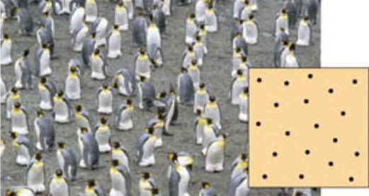

15. During a major natural wildfire, many of the populations of organisms surrounding the area decreased dramatically. What type of factor decreased the population sizes?
a. density-dependent factor
b. density-independent factor
c. limiting factor
d. carrying capacity factor
16.Which of the following would cause a population’s size to increase?
a. there are more births, but emigration is taking place
b. there are more deaths than births
c. there are more deaths and migration is taking place
d. there are more births than deaths

17. What is the term used to describe the maximum population an ecosystem can support?
18. A population of zebras has been getting attacked by tigers, causing their population to decline from predation. What is this an example of?
a. density-dependent factor
b. carrying capacity
c. density-independent factor
d. limiting factor
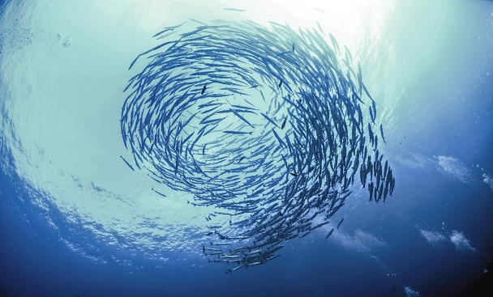
19. What type of dispersion is depicted in the image below of fish?

20. What factor would decrease a population’s size?
a. when there are deaths and immigration taking place
b. when there are more deaths than births
c. when there are less births but more deaths
d. when there are more births than deaths
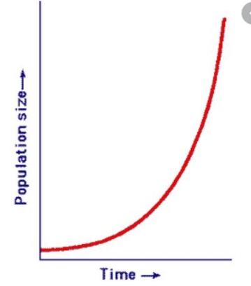
21. Looking at the graph below, what type of growth curve is this?

Ecosystems: Succession, Aquatic ecosystems
22. List a few examples of biotic factors.
23. After an ecosystem has been established from succession, the group of plants and animals remains stable. What is this type of community called?
24. A fire ruined an entire ecosystem. Since the setback, the soil became fertile again and started growing small plants and trees. What is this an example of?
25. Why can’t people scuba dive far down into the open ocean? Hint: think pressure and temperature that far down….
26. After a volcano has created new land, a species of lichen comes along and begins to break down rock, turning it into soil. What is the lichen considered?
a. a secondary succession species c. a pioneer species
b. a volcanic species d. a succession species
27. Michelle hikes in an area that can experience both a wet and dry season. What type of ecosystem is she hiking in? Hint: found only in Florida…..
28. What is formed when a river meets the sea?
29. A scientist comes across a shallow wetland that contains grass-like plants with no trees. What type of ecosystem did he come across?
30. If you were to see Hawaii after the land first formed from a volcano with no life present beyond lichen, what kind of succession would the island be in?
31. After hurricane Katrina hit in 2005, many aquatic organisms were affected by the lack of light getting into the ocean. What caused the amount of light to decrease?
a. the wind caused many organisms to be pushed close to the shore, cutting off the amount of light shoreline organisms received
b. the amount of floating particles (ex: sand and other sediment) increased due to an increase in wave activity, decreasing the amount of available light
c. the amount of organisms getting moved around caused the amount of light to decrease
d. the height of the waves affected the amount of light getting into the water
32. List three examples of abiotic factors in ecosystems
33. Why are there so few aquatic plants and phytoplankton that live at the bottom zones in the ocean?
a. most sunlight is absorbed before reaching these levels
b. the ocean farther down has less pressure that would kill aquatic plants
c. water is a limiting factor
d. the temperature in these zones is too high for plants to survive

Human Impacts on Ecosystems:
34. The common bush tail opossum is a marsupial native to Australia. This opossum was introduced to New Zealand where it had no natural predators and had an abundant food supply. What most likely happened to the population size of the opossums after a few years passed?
35. New fuels are being produced by converting corn and grasses into compounds containing alcohols that can be broken down for energy in various engines. The consequence of this is most likely to:
a. increase the rate of air pollution
b. cause a loss of biodiversity in the rain forest
c. reduce the use of nonrenewable resources
d. reduce the rate of homeostasis in organisms
36. DDT and other pesticides used over 50 years ago are still affecting the environment. Scientists have found these substances in recent glacier runoff. Ice layers from existing glaciers have been analyzed. Results show that the concentration of DDT and pesticides were highest above 10 years after the use of these substances was banned. The information shows:
a. that DDT and other pesticides cause glacier runoff during the summer time
b. that it takes humans 50 years to analyze a glacier
c. that the decision of one human generation may have an impact on future generations
d. that the precipitation helps to break down pesticides
37. The number of Burmese pythons found throughout the Everglades has increased in recent years. They aren’t native to Florida and are believed to have been released into the wild by pet owners. Biologists have initiated attempts to capture and remove these pythons, going as far as allowing hunting of them at an unlimited number. Which statement best explains the biologists reason for removing these pythons from the Everglades?
a. the pythons could prey on native organisms, causing native populations to decrease
b. the pythons could upset the territorial boundaries of organisms
c. the pythons could adapt to overcome diseases common to native snakes
d. the pythons could begin to interbreed with native snakes and produce a more successful species
38. Salt water is an abundant resource but is unusable for irrigation and drinking water. As the demand for fresh water increases, the use of desalination processes to remove salt from ocean water increases. A concern of desalinating water is the large amounts of recovered salts that are returned to the ocean. Which of the following describes the most likely impact of desalination on the surrounding ocean environment?
a. the salt going back into the ocean wouldn’t have any negative impacts on aquatic organisms
b. nonrenewable resources would become more depleted in the ocean
c. increased levels of salts and minerals in the ocean would result in overpopulation
d. alteration in ocean salt levels would cause loss of species
39. The presence of wastes, such as plastic bags and motor oil in lakes and streams miles away from developed area suggests that
a. ecosystems are interconnected, and human action can alter ecosystem equilibrium
b. recycling programs have failed to conserve biotic resources
c. natural processes can alter ecosystem stability
d. direct harvesting practices have led to irreversible destruction of ecosystems
40. The pH of the water in several lakes in Norway and Sweden had decreased to below 5.0 due to an increase in acid rain. Which of the following is most likely to happen in these lakes?
a. an increase in the number of fish
b. an increase in the amount of primary producers
c. the decline of several fish populations
d. increased predator-prey relationships
41. The northern elephant seal was almost hunted to extinction (only around 100 were left). It greatly reduced the gene pool of the population. What will be the consequence of this reduction?
a. competition within the population for food will increase
b. the elephant seals will be more vulnerable to environmental change
c. inbreeding will be less frequent among the remaining population
d. the surviving seals will be better able to adapt
42. A mining company wants to lease land that is currently part of a national park. They promise to reclaim the land should any minerals be mined from the area and are willing to pay top dollar for the rights. As an ecologist, what factors would you raise with the local government?
a. the threat to local biodiversity
b. the new jobs that would be created
c. the increased traffic in the area
d. management of the land after they leave
43. A community is concerned about the water quality of a nearby lake. Increased sedimentation in the lake is endangering the native habitat. The increased sedimentation is most likely caused by which of the following?
a. trees planted along the shore of the lake
b. an increase in the amount of fish in the lake
c. construction of homes along the lake
d. the amount of sunlight on the lake

44. Whaling was a profitable profession until whale populations crashed. The global community came together to enact a ban on whaling, but Japan and Norway haven’t agreed to stop whaling. Which of the following is the most likely consequence of their decision?
a. the whale populations are bouncing back very successfully and are unaffected by Japan and Norway
b. the whale populations have mutated into new kinds of organisms
c. the whale populations aren’t rebounding as quickly as they might if all the countries agreed to not hunt whales
d. the whale populations have increased, even near Japan and Norway
45. Why are scientists so concerned about the increase in use of nonrenewable resources that can speed up global warming, leading to more drastic climate change?
a. they are afraid it will cause mutations in many organisms, increasing the size of many populations and the environment won’t be able to support them
b. they are worried that as more carbon dioxide is given off by these resources, we are increasing the rate at which sea levels rise and organisms being affected by the change in global temperatures etc.
c. they are worried it will start to diminish the amount of renewable resources we have
d they are only concerned about a few areas of our planet that are believed to be changed or influenced by climate change

