Study Guide: Anatomy and Physiology Midterm Exam
1. The elbow is ___________ to the fingers.
2. The sternum is ______________ to the skin.
3. The arms are _______________ to the chest.
4. The ability to maintain stable internal conditions even though the outside world changes continuously is known as what?
5. Insulation, long term energy storage, and cushions for organs are functions of what macromolecule?
6. What elements make up proteins?
7. What macromolecule is cholesterol?
8. What would happen to an enzyme if the environment it is adapted to suddenly changes?
9. What body plane cuts the body into superior and inferior parts?
Tissues
10. Which of the following heals the quickest after an injury?
a. tendons b. nerves c. cartilage d. epithelium
11. The study of tissue is a type of gross anatomy called what?
12. What tissue type is responsible for veins, and moving food and waste?
13. What type of tissue makes up goblet cells?
14. List examples of connective tissue.
15. What muscle tissues are involuntary?
16. What muscle tissue has intercalated discs?
17. What type of tissue makes up the epidermis of the skin?
18. What is the first step of the inflammation process when tissues need repair?
19. Write down the steps to tissue repair in the correct order.
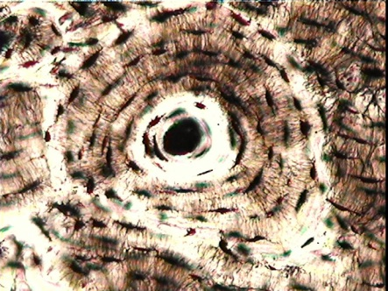
20. Looking at this tissue, what type is it?

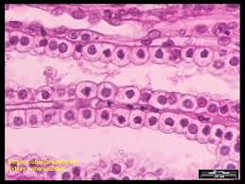
21. Looking at the tissue below, what type is it?

22. What is skin color determined by?
23. Acne is a disorder involving what glands?
24. What is the uppermost layer of the skin?
25. If someone is a cyanotic, what would they look like?
26. Why does Caucasian people’s skin appear white?
27. A patient experiences burns on one entire leg, one entire arm, and the anterior portion of their face. What percent of their body have they burned?
28. What are some complications of 3rd degree burns?
29. What does yellowing of the skin indicate?
30. What system is used to determine the percent of burns on someone’s body?
31. What is the most dangerous form of skin cancer that grows rapidly and is resistant to chemo?
32. What substance does your ear secrete?
33. Explain Wolff’s law.
34. List five types of bone fractures.
35. Why is bone considered an organ?
36. What fracture is common in sports fractures?
37. What fracture is common in children?
38. Osteoclasts, osteoblasts, proteoglycans and collagen fibers make up what component of bone?
39. What is the function of yellow marrow?
40. What hormone is produced in response to high calcium levels?
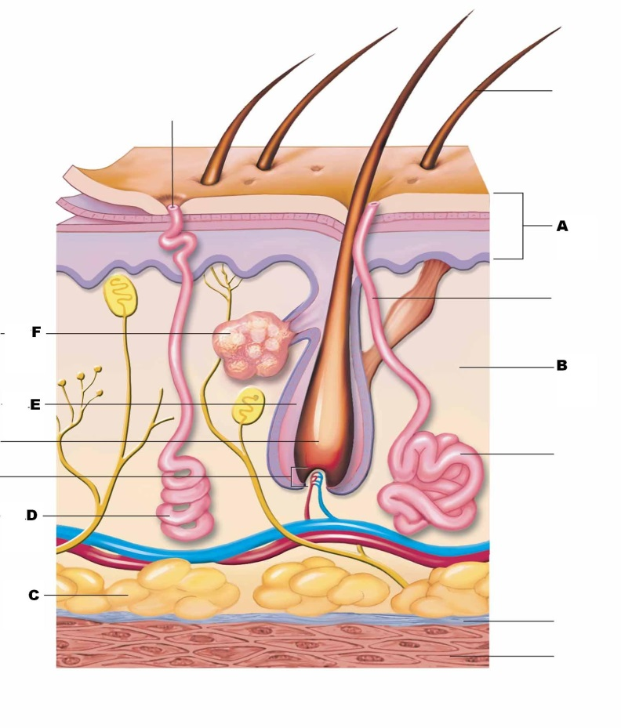
Skin diagram:

41. What is D pointing to?
42. What is F pointing to?
43. What is C pointing to?
Skull:
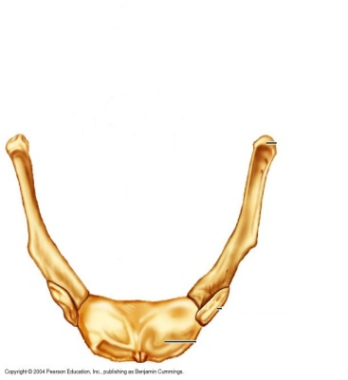
44. What bone is this? 45. What is A pointing to?
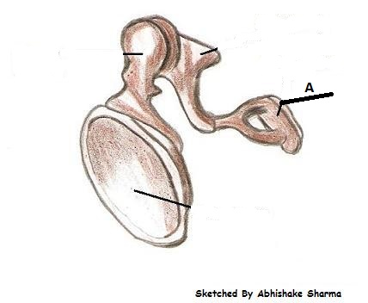

46. What is the name of the forehead bone?
47. What is the name of the cheekbone?
48. What are the tiny bones located at the site of the tear duct?
49. Name the four bones that contain the sinuses.
50. What bone is the tongue attached to?
51. Name two reasons why a baby’s skull should not be fused at birth.
Axial Skeleton
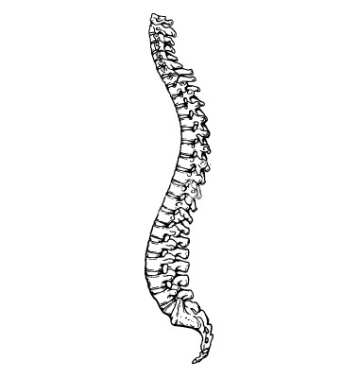
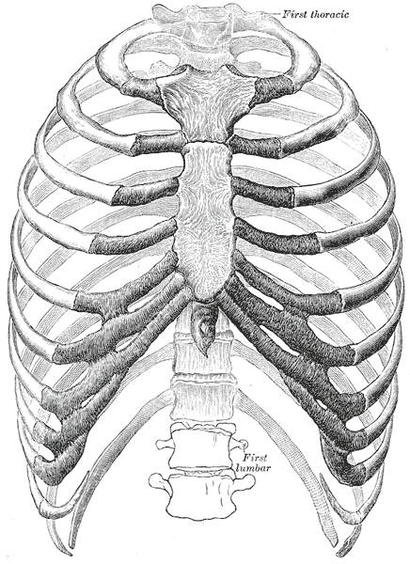
52. Label the three parts of the sternum. 53. Label the first two vertebrae.

54. What vertebrae allows you to do the “no” motion?
55. What is the opening in the skull called that allows the spinal cord to pass through?
56. What part of the sternum can cause damage to the liver?
57. How many vertebrae are in the thoracic region?
58. How many pairs of “true” ribs do you have?
59. What is the function of the discs in your spine?
60. What type of curvature are you first born with?
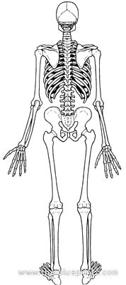
Appendicular Skeleton (#61-64)

63.
61.

64.

62.

65. What three bones make up the elbow?
66. What gender is the pelvic angle greater in?
67. What are the intervertebral joints and pubic symphsis examples of?
68. What are four factors that stabilize joints?
69. What are flattened sacs of lubricant associated with synovial joints called?
Joints: Directions: Match the movements with their descriptions:
A. adduction B. extension C. abduction D. flexion E. dorsiflexion
70. Moving away from the body
71. Decreasing the angle of a joint
72. Increasing the angle of a joint
Directions: Match the following joints with the ligaments below:
A. coxal B. elbow C. shoulder D. knee
73. corocohumeral ligament
74. iliofemoral ligament
75. oblique popliteal ligament
76. ulnar collateral ligament
Directions: Match the arthritis with the correct characteristics:
A. gouty arthritis B. Rheumatoid arthritis C. osteoarthritis
77. high levels of immune antibodies
78. high levels of bone spurs, worn down articular cartilage
79. What is a stretched or torn ligament called?
Muscular System
80. The contractile unit of the muscle cell, z disc to z disc is called what?
81. What is it called when the epimysium ends in a sheet?
82. When does muscle shortening occur?
83. What is a motor unit defined as?
84. What type of respiration occurs when lactic acid builds up?
85. What is the most efficient way to harvest energy?
86. What are the effects of aerobic exercise?
87. Which muscle is named for its shape?
a. zygomaticus b. gluteus maximus c. deltoid d. adductor longus
88. What muscle is used in smiling?
89. What is the prime mover of inspiration?
90. What muscle allows a ballet dancer to point their toes?
Be able to identify the following muscles from your muscle packet or textbook:
91. rectus abdominus 96. trapezius
92. Sartorius 97. Latissimmus dorsi
93. pectoralis major 98. Rectus femoris
94. deltoid 99. Orbicularis oculi
95. gluteus maximus 100. Biceps brachii
Nervous System
101. Impulses are taken from the central nervous system by _________________________________
102. What is the large fiber tract that connects the two hemispheres?
103. Which part of the brain is responsible for coordination of skeletal muscle movement (balance etc.)?
104. What area of the brain is responsible for higher level thought and reasoning?
105. What do dendrites do?
106. What area of the cerebrum allows us to say words in a correct order?
107. When is the sympathetic nervous system important?
108. How would the effect of epinephrine released by the sympathetic division on the heart affect it?
109. What month of pregnancy does the nervous system develop?
110. What neurotransmitter is found at every neuromuscular junction?
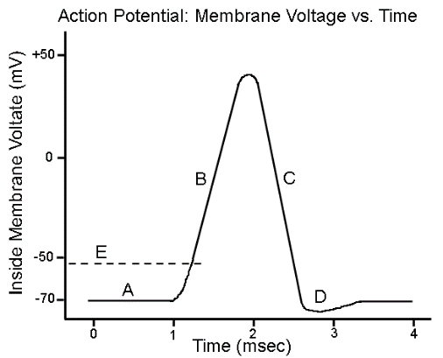
Be able to identify depolarization, repolarization, resting potential, and hyperpolarization on an action potential graph.
111. hyperpolarization
112. repolarization
113. depolarization
114. resting potential

