Rates of Evolution

I.) Two Different Theories about the Rate of Evolution

A. Gradualism -

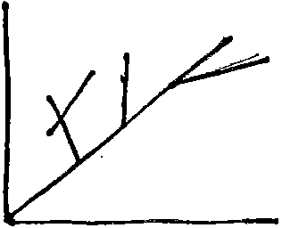
B. Punctuated Equilibrium -

II.) Three Types of Natural Selection

- Directional Selection -

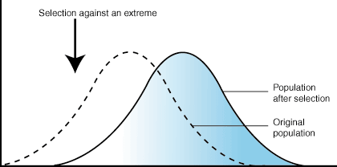ii'.'..

Stabilizing Selection –

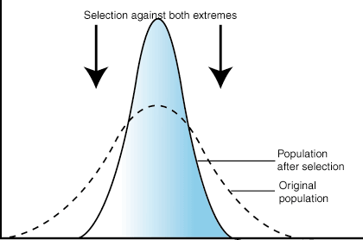

- Disruptive Selection -

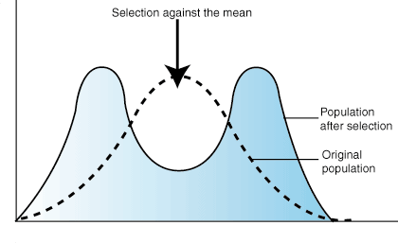

III.) What allows or does NOT allow speciation to occur?
Speciation -

A. Geographic Isolation -

Through mutation, natural selection, and genetic recombination each group evolves a new gene pool.

Examples:

1.
2.

3.

4.

Describe an example of how geographic isolation can cause speciation.
Reproductive Isolation –
1.
2.
3.
4.

*Therefore, geographic isolation can lead to reproductive isolation. Other factors related to evolution:
- Convergent Evolution -

- Divergent Evolution -

C. Adaptive Radiation -

D. Coevolution -

What do you think are some examp1es of coevolution?

Questions

- A species of brown ant lives in the grass and brush of the African rainforest. Habitat and food becomes scarce. Use a term and describe what you think will happen?

- A certain species of bird lives on top of a rhino. The bird eats insects off the rhino keeping the rhino from
becoming ridden with insect bites. l\1ost likely these two species have?

3. There is a species of marsupial with the common name "Tasmanian wolf.” Many believe this marsupial
resembles a wolf. What is this an example of?
4. A rate of evolution, in which organisms skip intermediates because the rate of evolution is fast, is called
_________________?
5. Using the three examples of natural selection draw which one you think would represent a change in a
population of rabbits that range from white to black, to a population in which white and black are
eliminated.

  - In general, organisms have variation, which allows for some individuals to be better adapted to their environment. Those organisms that are better adapted will survive and reproduce
And pass on those genes_ to their offspring. After many, many, many generations evolution occurs,

- If the environment changes, there is a better chance of survival for that species if there is more
The best adapted individual may become the least adapted individual in a different environment.

Review
- List 5 conditions that can disrupt genetic equilibrium and cause evolution to occur.

- Explain the role of mutations in evolution.

- Contrast stabilizing, disruptive and directional selection.

- Contrast the model of punctuated and the model of gradualism evolution.

