Review for Unit 1 Test
1. Carmen conducted an experiment to determine if listening to different types of music would affect a person’s pulse. Her hypothesis was that pulse rate would change with different types of music. Each person listened to seven different selections of music for 30 seconds each. Each person’s pulse was taken before the music and then after each 30-second interval of music. The pulses were taken again after the music selections were completed. Based on her experiment, Carmen concluded that a person’s pulse rate changed when the person listened to different types of music.
Which component is missing from Carmen’s experiment?
A. a question
B. a hypothesis
C. a control group
D. a description of the experiment
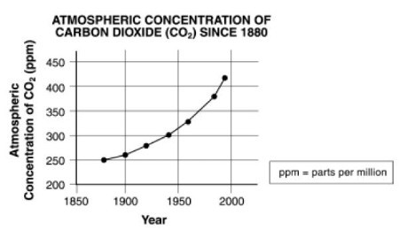
2. The graph below shows atmospheric carbon dioxide levels since the year 1880.

Which of the following conclusions can be drawn from this graph?
A. Atmospheric carbon dioxide levels are responsible for global temperature change.
B. Atmospheric carbon dioxide levels have been rising at about the same rate for the past century.
C. Atmospheric carbon dioxide levels have remained the same over the past century.
D. Atmospheric carbon dioxide levels have been rising at an increasingly higher rate as the past century has progressed.
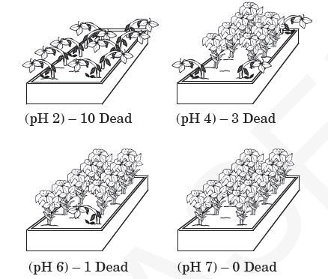
3. A scientist performs an experiment to see if acids have an effect on the health of a particular type of plant. Three sets of plants were treated with acidic solutions of known pH while the control set was treated with a solution of neutral pH 7.

Which is the best conclusion for this experiment?
A. Acid has no effect on the health of this type of plant.
B. High acidity is helpful to this type of plant.
C. Low acidity is harmful to this type of plant.
D. High acidity is harmful to this type of plant.
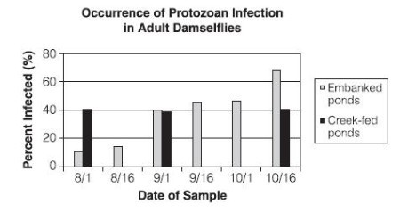
4. A research group has discovered that damselflies, a type of dragonfly, are being infected by a particular type of aquatic protozoan. Both young and adult damselflies are not directly infected by the protozoan but contract the infection from the prey they eat. The graph shows the percentage of adult damselflies infected by protozoans during the summer and early fall.

Which of the following conclusions is supported by the graph?
A. Infection in embanked ponds increased during the sampling period.
B. Protozoans were more common in creek-fed ponds than embanked ponds.
C. Protozoans reproduce more quickly in embanked ponds than creek-fed ponds.
D. Infection in creed-fed ponds remained constant throughout the sampling period.
5. If a company claims that its product has been proven scientifically, which of the following should have taken place if the results are to be considered reliable?
a. the company should have held discussions with leading industry scientists
b. technology should have been used in both gathering of data and data analysis
c. results should have been peer reviewed and repeated producing the same findings
d. the results of the investigation should have been published in popular magazines
6. A student is conducting an investigation to determine the effect of temperature on the metabolism of yeast. Yeast and sugar are added to water, the gas produced is captured, and its volume recorded. Which variables should be held constant?
a. mass of sugar and water temperature
b. mass of yeast and mass of sugar
c. volume of gas and water temperature
d. volume of gas and mass of yeast
7. Which of the following best describes a result of the polar nature of water molecules?
a. water molceules attract one another
b. the volume of water decreases by nearly half when its frozen
c. water molecules repel each other
d. water molecules repel most other substances
8. Water has a much higher specific heat than most other covalent compounds. What do you predict might happen if water had a lower specific heat instead?
a. flooding would occur and animals would be forced to migrate
b. harmful organisms living in water would reproduce at a rapid rate
c. organisms that are sensitive to changes in temperaturewould die
d. plants would not have enough water to carry out photosynthesis
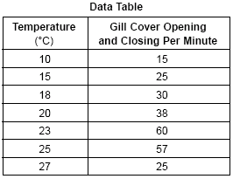
9. The rate of respiration of a freshwater sunfish was determined at different temperatures. The rate of respiration was determined by counting the number of times the gill covers of the fish opened and closed during 1-minute intervals at the various temperatures. The following data was collected.

a. What is the independent variable in this experiment?
b. What is the dependent variable?
c. Is there a control group?
d. According to the data, as the temperature increases, the rate of respiration of the sunfish:
(1) increases steadily
(2) decreases steadily
(3) increases, then decreases
(4) decreases, then increases
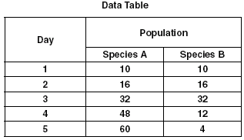
10. A biology student performed an experiment to determine which of two species of single-celled organisms would survive best when together in a certain environment. The student placed 10 organisms of each species into a large test tube. Throughout the experiment, the test tube was maintained at 30°C. After the test tube was set up, the population of each species was determined each day for 5 days. The data collected is shown in the table below.

a. What is the independent variable in this experiment?
b. What is the dependent variable in this experiment?
c. What is an example of a control variable in this experiment?
d. The difference in the population sizes on the fifth day most likely resulted from:
(1) temperature changes
(2) variations in light intensity
(3) competition between species
(4) the buildup of nitrogen gas
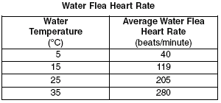
11. Three students each added equal volumes of pond water to four beakers and placed each beaker in a different water bath. Each student maintained the water baths at temperatures shown in the data table. The students then added an equal number of water fleas to each of their four beakers. After one hour, the students used microscopes to determine the average heart rate of the water fleas. The procedure was repeated for a total of three trials at each temperature. The results of the investigation are summarized in the data table.

a. What is the independent variable in the experiment?
b. What is the dependent variable?
c. What is an example of a control variable that should be held constant?
12. Which would be the most dense and have the most mass, 100mL of water or 100mL of ice?
a. They would be equal in dense and mass
b. Ice
c. Water
d. It would depend on the container
13. Why does ice float?
14. A water strider (an insect) can walk on top of water. What property of water allows this to occur?
a. Capillary action c. High specific heat
b. Magnetic properties d. High surface tension
15. We say that water molecules are ______ because they have a positive and a negative end.
a. Elements c. Magnetic
b. Non-polar d. Polar

16. Because of their oppositely charged ends, water molecules stick to each other very well. The word used to describe this is ____.
a. Specific c. Magnetic
b. Cohesion d. Capillary
17. Why is water called the "universal solvent"?
a. Everything in the universe will dissolve in water
b. Water completely dissolves in almost any material.
c. A large number of substances will dissolve in water.
d. If you had enough water, you could dissolve the entire universe in it.
18. Which of the following is an example of a biotic factor?
a. Water c. Sand
b. Sunlight d. Cells
19. Which of the following is an example of an abiotic factor?
a. Cells c. Water
b. Plants d. Bacteria
20. Which of the following is the variable in an experiment that a scientist can manipulate/change (it is something they vary)?
a. Independent c. Interdependent
b. Dependent d. Control
21. List two characteristics that make up a living organism.
22. Which of the following is the variable in an experiment that a scientist has no control over?
a. Independent c. Interdependent
b. Dependent d. Control

