Evolution, Origin of Life, and Classification Study Guide
1. What does the fossil record indicate about horses when the oldest horse on record was small with no hooves, and the modern day horse is tall with hooves?
2. Hind bones in whales and hips in snakes are what types of structures?
3. Why is it important that many wild animals have litters of offspring when it comes to natural selection?
4. What does “survival of the fittest” mean in terms of traits?
5. Looking at the picture below, what type of structures are these considered?
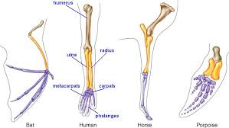

6. What can early embryology between different species of organisms show scientists about evidence of evolution? Think of relation!
7. When two very different organisms occupy the same niche and have evolved a similar body form, such as a dolphin and shark, what type of evolution is it?
8. When a population of squirrels becomes separated into two separate groups due to an earthquake, and cross paths with one another after 5,000 years, they can’t reproduce. What type of isolation is this?
9. When a litter of puppies are born, a breeder notices the puppies have different coat colors. What part of Darwin’s idea of natural selection is this?
10. What are the five steps of natural selection in order?
11. What would happen when there is a separation of a population of organisms when it comes to speciation? Hint: Will they go extinct, or will they evolve differently?
12. The finches that Darwin studied have a variation in the shape of their beaks. Why is this?
13. What was produced in the flask after several days of Miller-Urey’s famous experiment?
12. Explain what gene flow is, and give an example!

13. In what way does modern evolutionary theory differ from Darwin’s theory of evolution? Hint: what types of advances have we had to test theories? Think of genes….
14. What are some effects of genetic drift on evolution?
15. What is a group of organisms that breed with one another and produce fertile offspring?
16. What effects has human encroachment had on organisms?
17. What is mimicry?
18. Why did Linnaeus develop his system of classification?
19. What are the two ways in which nutrition is gathered?
20. What is a property that could be used to distinguish between an organism in the domain Eubacteria and the domain Eukarya?
21. What are modern classification systems based on?
a. solely on structural characteristics of organisms
b. on similar behaviors as well as similar characteristics
c. solely on evolutionary relationships between organisms
d. on evolutionary relationships as well as similar characteristics
22. What is the correct order of levels of classification from broadest to narrowest (don’t include domains in this case)?
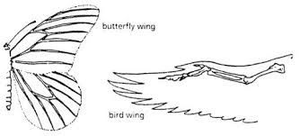
23. Looking at the picture below, what type of structures are these?

24. There are organisms that are multicellular and able to create their own food. What kingdom do they belong to?
25. What kingdoms beyond animals are made up of entirely heterotrophic organisms?
26. Louis Pasteur tested the idea of spontaneous generation. Why did bacteria grow in the straight necked flask but not the swan necked flask?
27. What kingdoms have photosynthetic organisms?
28. What is the trend in the fossil record of humans?
29. Why did jaw size in hominids get smaller?
30. What species of hominids were the first to create tools?
31. What species of hominids discovered fire? Why was that so important to hominid evolution?
32. What is the difference between convergent and divergent evolution?

